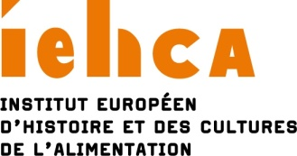

APPLICATION FORM

17th SUMMER UNIVERSITY
ON FOOD AND DRINK STUDIES
Tours/France, 25 August to 1 September 2019

Surname : First Name :

Date of Birth :
Adress :

Nationality :
E-mail : Tel. :
Academic institution :

I would like to apply for a place on the Summer University 2019.

If my application is successful, I agree to pay the €450 registration fee as follows,:
- € 200 as a non-refundable deposit upon allocation of a place, either by cheque (only if drawn on a French bank account) or by bank transfer (including possible bank fees),
- € 250 on the first day of the Summer University, either by cheque (only if drawn on a French bank account), by bank transfer (including possible bank fees) or in cash.

Bank details :
Institut européen d’histoire et des cultures de l’alimentation – Domiciliation Tours (00371)
RIB : 30004 00371 00010128856 58
IBAN : FR76 3000 4003 7100 0101 2885 658
SWIFT BIC : BNPA FR PP XXX

Please send the following items by 15 June 2019 :
This application form (fully completed)
An up-to-date CV with full details of education and academic / other distinctions
A summary of any research into the history and culture of food/drink already completed, currently in progress or planned (2-3 pages max. for consideration by the selection committee; please note that, in case of acceptance, a longer version of 3-10 pages may be submitted for circulation among all participants by the end of July)
A personal statement of why you wish to attend the Summer University
One letter of recommendation by an academic referee
I wish to be considered for a bursary: YES / NO (delete as appropriate)

Applications can only be submitted by e-mail to : olivier.rollin@iehca.eu

